VISIT Internship Meeting Minutes

# Meeting with Prof. Vashisth | Jul 7, 2023

* 1. Discussed the sources of error we could have in evaluating our result.
  2. Explained a couple of slides on Gpy-opt background, which Professor mentioned earlier.
  3. Discuss the two approaches we have for DoE for PEEK
     1. Taguchi
     2. CCD
  4. Discussed internship evaluation form.

# Meeting with Prof. Vashisth | Jul 5, 2023

* 1. Told sir about the pendig_X and ignored_X functionality available in the external evaluation of the objective function.
  2. I talked about the different kinds of GPs I tried and different acquisition functions.
  3. Also, confirmed that the default EI implementation in GPy-opt has an epsilon value of 0.01 (set as jitter in the model)
  4. Also, told that standard GP implementation has a matern 5/2 kernel implemented.
  5. To-do assigned:
     1. Look for different functions as said above and suggest a point to Ankush ASAP
     2. For PEEK, come up with a DoE. Prof. also asked Ankush to 3D print, treat, measure, paint and measure.
  6. After this, Prof taught me about MD, Graphene and Carbon Nano Tube. He also asked me to look into the equilibrating CNT problem

# Meeting with Prof. Vashisth | Jun 30, 2023

* 1. Explained the Google Colab code to sir for suggesting the next point. When I mentioned the different types of GP and acquisition functions he asked me to chugg and play them into the model before the next meeting.
  2. Prof. also mentioned the domain for varying different parameters for PEEK
     1. SOD (6.5 - 13) with each step being 0.5
     2. Speed (0.5 - 15.5) with each step being 0.5
     3. #Passes (integers in the range 1 to 50)
     4. Flow rate (10-85)
     5. Nozzle rpm (1000-2800)
  3. We then compared the PEEK wet and dry tape test results
  4. I also presented three papers to the professor that were the applications of BO
     1. Application in pharmaceutical
     2. Synthesis of short polymer fiber materials
     3. Sir’s data science paper

# Meeting with Ankush | Jun 28, 2023

* 1. Ankush said that we can not try the newly suggested set of parameters based on PEEK because it is based on thermoset data.
  2. He also asked me to discuss the following things with Professor in the upcoming meeting:
     1. Should we take both SA and CA or anyone would work?
     2. Wet tape test results for peek coupon
     3. Discuss the length and breadth of the samples
     4. Peek accelerated cure?
     5. Peek coupon doe?

# Meeting with Prof. Vashisth | Jun 26, 2023

* 1. Showed wet tape test and dry tape test results to Professor. Compiled them into a table together.
  2. After we had figured out that we have to make the external evaluation of the objective function, I assigned myself to check more about the choice of mean and covariance functions used in GP
  3. Also, to look into different types of acquisition functions and when to use what type of function.
  4. Introduced the Gpyopt package to sir. Professor suggested that include some slides on the background of Gpy-opt.

# Meeting with Prof. Vashisth | Jun 21, 2023

* 1. Discussed the realisation that we have to parallely evaluate and supply datapoints to the model rather than getting all the datapoints once and then giving it to the model as input. Was an unplanned meeting so could not prepare PPT.
  2. Was assigned the task to look into the implementation of evaluation of BO from outside.

# Meeting with Prof. Vashisth | Jun 19, 2023

* 1. Explained the DoE document to the professor. I proposed him four methodologies that were present for the dealing with quantative input variables.
  2. I also seeked Professor’s inputs on how to scale our domain of the input space to the 4 or 5 levels that we have in design. He guided me that in these type of cases I should be ready with all the methods, stating their comparisons and then ask the professor about which is the best one.
  3. Professor asked me to conform the precision and the domain available with us for the all the three surface parameters contacting Ankush and Eric. Tag and send email.
  4. I also double checked the method of analysing images (Use polygon cropping). The results were slightly unexpected as we expected that the pristine would behave badly and give us a score of about 25-30 while it was giving 86.
  5. Tasks assigned till next meeting:
     1. Be sure about the bounds and precision for the three input parameters. Discuss it with Ankush and Eric.
     2. Think about how to scale our domain to 4 or 5 levels in the design.
     3. Update all the ImageJ data
     4. Focus on BO → objective function
  6. 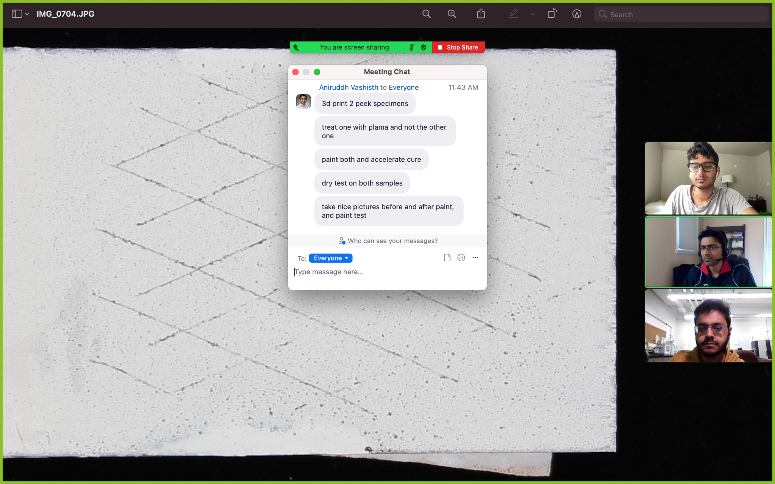

# Meeting with Prof. Vashisth | Jun 9, 2023

* 1. Explained to Prof. the working of the code.
  2. The major questions Prof. had were:
     1. When you add a new data entry, it is based on a surrogate, which is not a real entry to train your data on.
     2. Does self-defined objective function work? Possible ways to optimise an objective function.
     3. Asked Ankush to send an email to let us know how many new samples we can get.
     4. Ankush gave his insights on
        1. If #passes inc, speed dec, residence time inc, chemical func inc, sample reacts quickly with the environment, paint performance decreases.
     5. Professor again reiterated that
        1. Processing parameters to paint adhesion is application. This is our first step.
        2. Processing parameters to surface characteristics is the science. This is our secondary objective.
     6. Professor shared with me the chronological steps, I need to follow.
        1. Step 1: Wait for the Paint Adhesion Result. Use ImageJ to analyse images and get a continuous value for our result in the range 0~1.
        2. Step 2: Run the BO model with Processing parameters. (Be foolproof in all aspects at this step).
        3. Step 3: Design a DOE with a new set of processing parameters.
        4. Step 4: Keep the last few samples to check for the solution you get from your BO model.

# Meeting with Prof. Vashisth | Jun 5, 2023

* 1. Mentioned to Professor about the nature of input data. For eg., we have SOD values as only 6.5 and 13. To which he agreed and we came to some solution of using the function

XPS = f(A) = (Passes + 1/SOD + 1/Speed)

But this has its own problems. Suppose we optimise it for the variable f(A), how would we get the values of individual components from this value.

* 1. Professor reinstated that the output data from scratch test would be a continuous value from 0-1. This can be calculated from the ImageJ software where we can get the % area removal.
  2. Professor also mentioned to Ankush that we would be doing the wet-tape adhesion test. We will be doing the worst case test for the adhesion test.
  3. Do not do Random Forest and Decision Tree model.
  4. Primary tasks till the next meeting:
     1. We will condense to BO. Lookup BO for three dimension. Look into Yiwen’s 64 dimensional code link he sent.
     2. Look into image analysis things.

# Meeting with Ankush | Jun 2, 2023

* 1. Showed him the Decision tree model
  2. Tried out the predictions for best and worst case scenarios. One of the practical conclusion we could draw from the model was that for speed of 15 mm/s and SOD 13 the minimum number of passes which are required to Pass the test is 16.
  3. The Decision Tree model we made was based on the assumption that samples showing XPS value above 30 were taken to be ‘Pass’.
  4. Ankush also mentioned the apprehension that it might be the case that our final results may not be dependent on the three parameters we specified and all the samples with XPS above 20 would give a ‘Pass’. Thus, we would not require any ML model for prediction. Overall, it is research :/

# Meeting with Ankush | May 30, 2023

* 1. I asked Ankush whether the data we have is discrete or not. Since I tried running the GP code on the data, and it simply said NO because of the type of data we had. Ankush answered that it is difficult to get continuous sort of data because even if he changes the SOD from 13 to say, 12, the equipment we have will not be able to measure the changes we encountered.
  2. For the kind of data that Ankush mentioned, it just struck me that Decision trees might be a good model for it and I have to try that.
  3. We can not get XPS data. It would take around two months for the XPS data to come from outside. So we have to deal with whatever the data we have.
  4. The question Boeing would ask is, “Given the transnational speed of 100 mm/s, what should be the number of passes and standoff distance that would make the test ‘Pass’?
  5. Ankush asked me to find trends in data. For example, we can keep one parameter/two parameter constant and then try to see how XPS or other surface properties change with the changing processing parameters.
  6. He asked me to consult ML peeps if they can help with some of their knowledge
  7. If I have to get some data, it will take almost **TWO WEEKS** for Ankush to get the data for me. This is because we have to leave the paint on the samples for about a week now.

# Meeting with Prof. Vashisth | May 30, 2023

* 1. Asked Professor about
     1. Starting with linear regression, Professor mentioned, and I also recognised that we don’t have enough data for it. There is also a possibility of trying for Polynomial regression.
     2. I mentioned that I tried linear regression but did not get coefficients. This might be due to any of these two reasons:
        1. Small dataset
        2. Maybe I did not apply the backward and similar things on the dataset.
     3. I mentioned that I tried fitting GP, the model fit on whatever the dummy data I had, but I was not able to get the equation of the curve.
     4. If we are to get the equation only, then Prof and I jointly questioned why we need the Bayesian Optimisation and how it is different from Linear regression and other regression models. I then mentioned how BO is applied in that UBC youtube video, but how is the implementation done on the scikit learn website? There is no iterative aspect on the scikit learn website.
     5. In continuation to this, Professor shared an [article](https://machinelearningmastery.com/what-is-bayesian-optimization/) which had the implementation of the BO.
     6. We then discussed the dimensionality of the data that can be fed to a BO code. With reference to that Professor asked one of his students to share a code who mentioned that he had seen [BO code for 64 dimensions](https://github.com/mkusner/grammarVAE#bayesian-optimization).
     7. One important thing sir mentioned was that we have three things:
        1. Processing parameters
        2. Surface properties
        3. Final scratch test

Our aim is to link processing parameters to the final scratch test (0-1 value). The link to the surface properties is the from properties is the physics of the problem and that is the secondary objective of our problem.

* + 1. I asked about the safety training to which Prof. answered that I do not need to do the training. Also mentioned about the table and after which I got a desk in G042:)
    2. To-do:
       1. Look at the data carefully and see what you can get from there.
       2. Go through the ML website.
       3. Go through the code sir shared
       4. Make a decision tree on paper | cancel
       5. Look up decision tree | d
       6. Look up random forest |
       7. Linear regression (backward thing)
       8. Polynomial regression
       9. Fitting equation using GP, getting the parameters of the equation (the thing sir shared) | w
       10. One input and one output prediction (get a working code)
       11. LITERATURE SURVEY | w
       12. Y as a function of all the processing parameters. Look up this thing, how to do it in literature.
       13. Look up GP (optional)
       14. Look about objective function

# Meeting with Prof. Vashisth | May 25, 2023

* 1. I mentioned that I looked for various ML algorithms.
  2. Discussed the need for an objective function and how can we come up with one.
     1. We discussed the most rudimentary form that we can come up with

XPS = A1*SOD + A2*Passes + A3/Speed

* 1. We can give less priority to contact angle at this point since there is a high chance that it is a function of XPS and Surface Roughness.
  2. Start by applying BO to relate one processing parameter with XPS. Although, this might not be additive to the final relation but something good to start with to gain familiarity with ML algorithms.
  3. Our main aim is **‘To minimize the paint removal area’**.

# Meeting with Ankush | May 25, 2023

* 1. Ankush gave me a few more details about the specific aspects of the project.
     1. XPS: Used to understand the chemical composition of the surface. There are two nested aspects to this XPS.
        1. Survey scan: This would tell us that we have oxygen on the surface.
        2. High-resolution scan: This would tell us what type of oxygen bonds we have on the surface and what is the percentage of these bonds.
     2. Contact Angle: As we move from pristine to plasma-treated surface wettability increases. The contact angle decreases.
  2. Ankush mentioned we have data of 13 coupons with us. 1 Prisitine and 12 treated surfaces. In continuation to that, Ankush asked me to confirm two things from Professor:
     1. Shall we take the %O from the survey scan, or should we deconvolute it to get the High-resolution scans?
     2. Should I (Somesh) take the contact angle measurements?

# Meeting with Prof. Vashisth | May 22, 2023

* 1. Prof. looked at the [Toy code](https://drive.google.com/drive/folders/1ipUgGx901MzInwmkMIwi_fzIsR9eECWJ?usp=share_link) I wrote for learning hyperparameters for SVM classifiers.
  2. He gave an explanation for the project which was the same as that given by Ankush. Additional details given by sir included
     1. Painting is like cooking. You do one thing differently and you will observe different results. We need an objective function
     2. BO is just one optimization technique. Keep your mind open for other techniques as well.
     3. Image processing and analysis would also be required from Somesh’s end at some point (not sure as of now). This is an extension to what Ankush told us where we are considering the ‘adhesion test’ output to be binary.
     4. Seeing the whole thing as (composed of)
        1. Processing parameters (nozzle speed, distance, flow rate, translational speed, no. of passes)
        2. Surface characteristics (roughness, chemical functionality, contact angle)
        3. Adhesion ( 0/1 or 0-1)

Now, it is up to us to link the three things mentioned in point (iv).

KEEP THINKING ABOUT THIS AT THE BACK OF YOUR MIND.

* 1. Instructions and expectations moving ahead:
     1. Professor expects a working code for the optimisation of the process (this need not necessarily be BO). And he expects that we will publish/present somewhere this successful work.
     2. I have to report weekly to Professor.
        1. For each weekly meeting, I should have a ppt (Weekly meeting time: Thursdays 2-3 PM).
        2. I am also required to maintain a running doc to record progress (This MOM, I propose, would serve the purpose).
  2. To-Do (s):
     1. Think about the problem
     2. Learning about BO?? Is this the correct algo to go with?
     3. How important 3 phases/components? What are the interplays between them?
     4. Try to make a rough timeline for yourself, including weekly goals.
     5. Look into the BO literature. The matrix with each cell having a value between 0 and 1.

# Meeting with Ankush | May 19, 2023

* 1. Revisited whatever we discussed in the May 18 meeting.
  2. Ankush introduced some new terms and asked me to read about them.
     1. PEKK. Plasma treatment on PEEK has been seen enough in industry. We are trying plasma treatment on PEKK (used heavily in aero industry composites).
     2. Optical profilometer (Keyence 3D Optical Profilometer VR6000 series): Takes image to judge surface roughness (surface morphology).
     3. Contact angle (goniometer)
     4. X-ray photoelectron spectroscopy.
     5. Plasma processing. Residence Time = f(no. of passes, translational speed)
     6. We use plasma (Less energy consumption, safe operations, less pollutants, cost benefit, less time). More info at [plasmatreat.com](https://www.plasmatreat.com/en/).
  3. We also discussed the format and high level contents of what I have to submit at IITGN in the first fortnightly report. Include one or two small paragraphs of whatever 6 points you have mentioned above.

# Meeting with Ankush | May 18, 2023

* 1. Showed me 125 lab
  2. Gave a detailed overview of the project and what would my role exactly be in the project.
     1. Composites when manufactured have their surfaces as hydrophobic.
     2. To increase the longevity (prevent environmental and UV degradation) of the composite material manufactured, we paint it. But since they are hydrophobic, the paint does not stick for a long time.
     3. To make the composite surface hydrophilic so that primer/paint stick on it for a longer time we can
        1. Change the surface texture
        2. Change the chemical functionality (reactivity) of the surface.
     4. One of the methods to bring the two aforementioned changes is ‘Plasma Treatment’. Plasma treatment can change surface functionality increasing reactivity of the surface.
     5. While we are doing the plasma treatment there are several parameters to control. These will dictate how effective the plasma treatment was and how much of adhesion we have achieved. These parameters are:
        1. RPM of the nozzle (constant)
        2. Volume flow rate (really?)
        3. Nozzle distance from the surface (two values to be examined)
        4. No. of passes
        5. Translational speed

Out of the five mentioned parameters, we want to optimize the process for only three: Nozzle distance from the surface, No. of passes, Speed (mm/s). The other two parameters (rpm and flow rate) have already been optimized by Ankush and we would keep them constant while doing the optimization.

* + 1. Once we have carried out the plasma treatment, we will measure the effectiveness of the process through three characterization techniques which will measure the following mechanical/chemical properties:
       1. Contact angle (of primer/paint on plasma treated surface)
       2. Amount of functionality, measured in % (XPS: X-Ray photoelectron spectroscopy)
       3. Surface morphology (mainly measured for surface roughness)

Another basic thing is the ‘standard scratch/grid test’. This would give us Pass/Fail. And we want to optimize, say, it is a fail for this nozzle distance, can we modify a bit to convert it to Pass

* + 1. We will have 3 datasets (one for each characterization technique) of 20 data points each to carry out the data processing or optimisations we are looking for.
  1. Showed the working of the plasma setup
  2. Asked me to get acquainted with BO as much as possible. Write a few toy codes to grab hands on.

# Meeting with Eric | May 15, 2023

Eric showed the labs 125 and the lab downstairs with the plasma setup. He also gave a brief overview of the project.